Ahsanullah University of Science and Technology

Department of Computer Science and Engineering

CSE 2210: Digital Electronics and Pulse Techniques Sessional Spring 2020

**Group: B2 Time: 40 minutes**

**Experiment #2**

**Name of the experiment: Study of a transistorized NOT gate.**

**CKT diagram:**

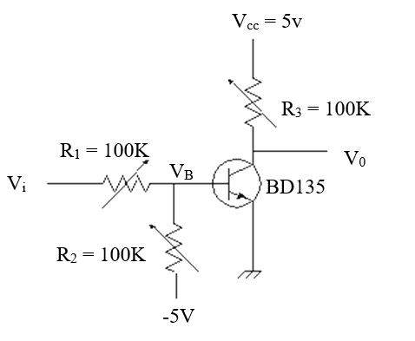

**Procedure:**

1. Fix the value of R1, R2, Vi and vary R3; measure V0 and VB.
2. Fix the value of R1, R3, Vi and vary R2; measure V0 and VB.

2) Fix the value of R2, R3, Vi and vary R1; measure V0 and VB. (Draw graph)

1. Fix the value of R1, R2, R3 and vary Vi; measure V0 and VB. (Draw graph)

**Questions:**

1. Which factor affect the switching speed of a transistor and how?
2. What is the effect of R1? Can it be very large?
3. Are there any effects of temperature on the circuit?

**Report:**

1. Objective.
2. Circuit diagram.
3. Answer to the questions.
4. Experimental data.
5. Calculations.
6. Discuss the findings.

**Procedure:**

1. Take any one fixed values within the given range:

R1= (1.6 - 3.2 )K

R2= (85 - 100) K

Vi = 5V

1. Take any one fixed values within the given range:

R1= (1.6 - 3.2 )K

R3= (35- 45)K

Vi = 5V

1. Take any one fixed values within the given range:

R2= (85 - 100)K

R3= (35- 45)K

Vi = 5V

1. Take any one fixed values within the given range:

R1= (1.6 - 3.2 )K

R2= (85 - 100)K

R3= (35- 45)K